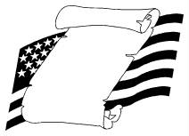
Constitution Day Webquest

Name: ________________________________________________
1. What is the Constitution? _________________________________
_______________________________________________________
http://www.usconstitution.net/constkidsK.html
--------------------------------------------------------------------------------------
2. When was the Constitution written? ___________________________
http://www.senate.gov/civics/constitution_item/constitution.htm
--------------------------------------------------------------------------------------
3. Who were two of the Founding Fathers? ________________________
and _________________________________________.
http://americanhistory.about.com/od/revolutionarywar/tp/foundingfathers.htm
--------------------------------------------------------------------------------------
4. How many parts is the government split up into? ___________________
List them here: _____________________________________________
_________________________________________________________
http://www.congressforkids.net/Constitution_threebranches.htm
--------------------------------------------------------------------------------------
5. How many delegates signed the Constitution? ____________________
http://www.congressforkids.net/Constitution_signingconstitution.htm

